10. Write a HTML program to add a background GIF to a webpage and alter its height, width,transparency and transition using Cascading Style Sheets.
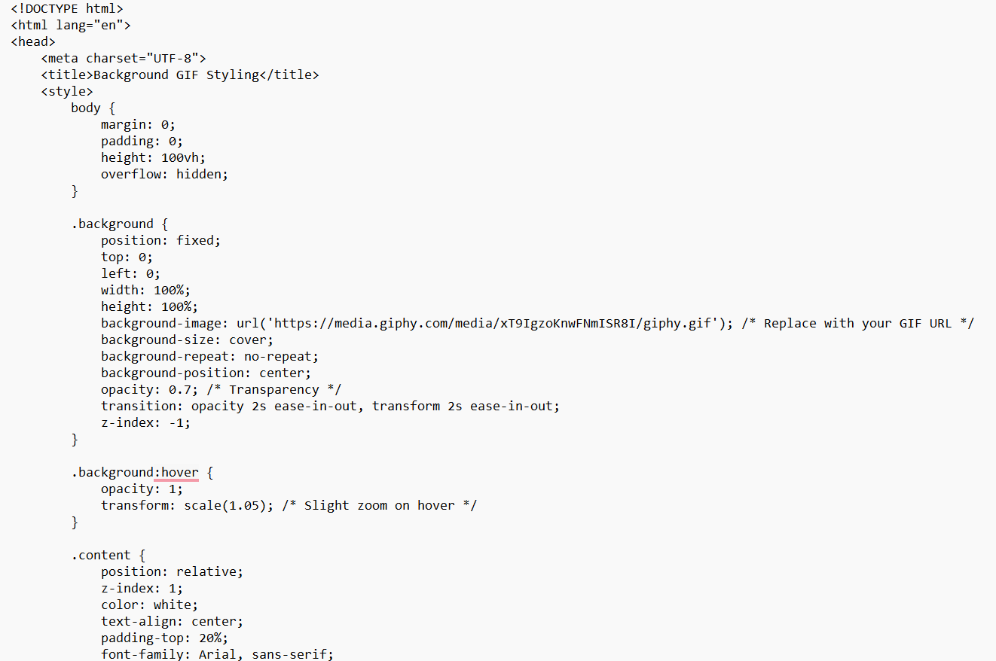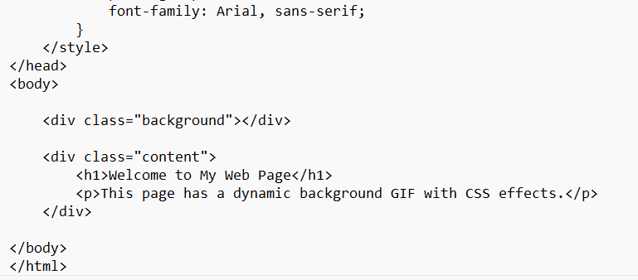

output
